Foundation for Food and Agriculture Research Convening Event Recap Report

Crops in Controlled Environments Convening Event

November 13, 2017 | Yorktown Heights, NY
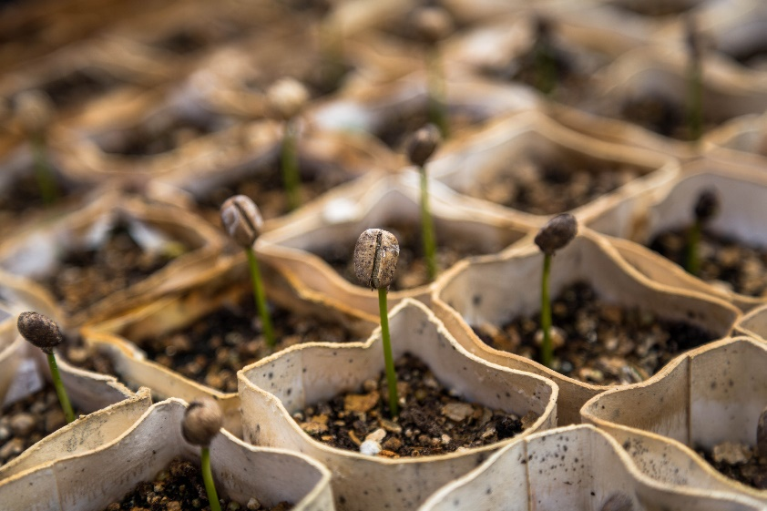
On November 13, 2017, the Foundation for Food and Agriculture Research (FFAR) held a convening event in an effort to advance FFAR’s Urban Food Systems Challenge Area. The Crops in Controlled Environments Convening Event was held in Yorktown, NY, at the IBM Thomas J. Watson Research Center. This event was one in a series of nine events held by FFAR across the country designed to seek stakeholder input for FFAR’s seven Challenge Areas in the last quarter of 2017.
The Crops in Controlled Environments Convening Event focused on determining the state of science and, most importantly, the areas where FFAR can catalyze research efforts to advance crop development for controlled environments. We explored areas of research where joint efforts in research between the public and private sectors could advance the field, including:
- Advances in the molecular understanding of traits required for controlled environments
“Controlled environment agriculture presents a challenging, but exciting opportunity for science. We are just scratching the surface on what is possible in this space and I am thrilled to see so many brilliant people working towards innovative solutions. There is nothing we can’t accomplish if we work together to create science-based approached to growing crops in controlled environments.”
-Sally Rockey, Ph.D., FFAR Executive Director
- Breeding crops for controlled environments and increasing nutritional content
- Methods for crop adaptation
- Environmental stressors to enhance qualities and nutritional content

Urban Food Systems Challenge Area
The Urban Food Systems Challenge Area aims to enhance our ability to feed urban populations through urban and peri-urban agriculture, augmenting the capabilities of our current food system. This Challenge Area will target research and technology development that includes, but is not limited to: production systems in urban and peri-urban environments, extended growing seasons, production of nutritious and climate resilient crops, and food system components that make food more accessible and affordable.
At FFAR, we recognize there are a number of critical challenges and key scientific priority areas through which FFAR and other key stakeholders can partner to become change agents focused on advancing urban food systems.

Importance of Controlled Environment Agriculture
Completely controlled environments offer opportunities unlike any we have seen before in agriculture. While nascent, no other production system has the capability of controlling every environmental aspect required for crop production, increasing our ability to influence the growth, development, and phenotype of crops. Although there are a handful of scientific experts who have advanced this field over the past few decades, it is still a burgeoning field where investments will yield a wealth of information that can spur a vast amount of innovation in fruit and vegetable production, transforming how production of food occurs for centuries to come.
As with most other sectors, the success of completely controlled environments will be determined by research investments, investments that will ultimately drive innovation and economic development in this burgeoning field. Currently, the US federal government funds some research in vertical production system (lighting, energy costs, and crop development); however, this funding is minimal and uncoordinated. Recently there has been a wave of venture capital investments, leading to a growing interest in vertical farms from young entrepreneurs with diverse backgrounds in computer science, physics, plant biology, and business. This increase in funding and talent alludes to the potential of completely controlled environments to transform agriculture and build new economic opportunities centered around crop production.
We live in an age where technology is rapidly advancing, and many young entrepreneurs from a range of scientific and business disciplines are beginning to push the boundaries of vertical production systems. This is an opportune moment to build on the advancements made in other scientific and engineering disciplines to elevate this field, helping to transform certain aspects of agriculture and recruit a new generation of technologically savvy and multidisciplinary farmers.

Convening Event Overview
At this convening event, part of the focus was on opportunities within controlled environments, including the crops that we can grow within these environments. Compared to other production systems, growing crops in controlled environments will shift our focus from traditional agricultural traits to more value-added traits. These traits will be a product of both genetics and environmental control, producing more nutritious and flavorful crops or crops that could be used in nutraceuticals, medicine, or in industrial applications. Non-food crops could drive innovation in this space, with advancements in engineering, lighting, and breeding paving the way for success.
As this field moves forward, advancements in this field must include data: increasing our capability to share data, increasing our capacity to collect data, and the metrics that are needed (flavor, nutrients, light treatment, yield/energy).

Outcomes and Next Steps
During the event participants were asked “What are the most promising opportunities in controlled environment agriculture?” .
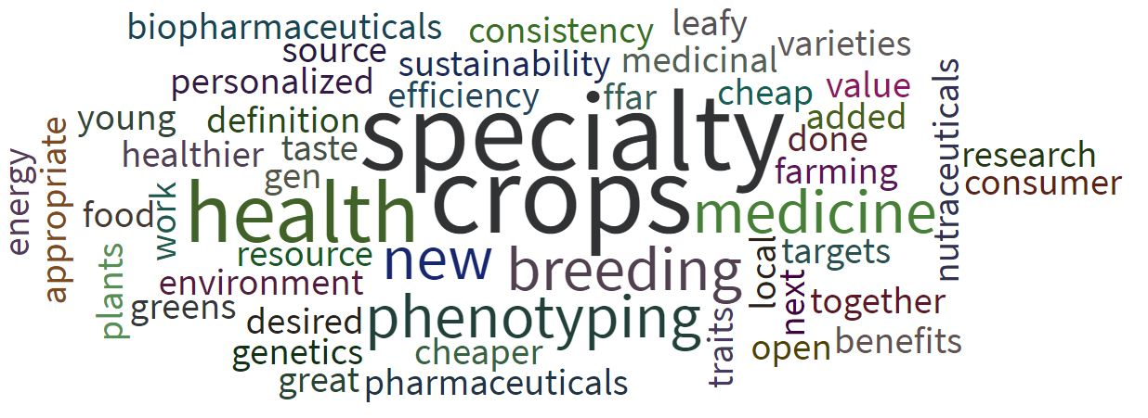
The overall response was in crops. However, growing crops effectively in these environments will require adaptation and a better understanding of traits as they relate to genetics and environmental inputs. Any efforts to breed crops in these environments should capitalize on knowledge gained from past breeding efforts . There are many opportunities for innovation within this space; however, there is currently relatively low-prioritization within the US government for urban agriculture. FFAR aims to build a pre-competitive consortium that will focus on developing crops for controlled environments.
If there are any questions regarding the event or its outcomes, please contact John Reich at jreich@foundationfar.org.

Stay Engaged
FFAR looks forward to continuing to build strong public-private partnerships within the agriculture community and welcomes your input. Please feel free to contact John Reich at jreich@founationfar.org to learn about how you can engage with FFAR.
To stay up to date on any upcoming convening event, paper, or funding opportunity related to Crops in Controlled Environments, please join the Urban Food Systems Challenge Area email list: http://bit.ly/ffarurbansystemslist.

Many thanks to our Event Speakers!
Caleb Harper, Keynote Speaker MIT Media Lab
Roger Buelow Aerofarms
Kevin Folta University of Florida
Eri Hayashi Japan Plant Factory Association
Chieri Kubota . Ohio State University
Brian Lanes PlantLab
Thomas Lubberstedt Iowa State University
Ard Reijtenbagh . PlantLab
Stephen Schauer KeyGene USA
Asheesh Singh Iowa State University
Matt Vail Local Roots
Zhijian “Tony” Li USDA, ARS
Mike Chirveno ClearVision Consulting
Ian Justus Driscoll’s

FFAR is also pleased to recognize the following event sponsors for their generous support:
IBM Research
Bayer Vegetable Seeds
KeyGene

